Year 9, chapter 4.2: Sound

What is sound?
__________________________________________________________________________________
__________________________________________________________________________________
What is a sound wave?
__________________________________________________________________________________
__________________________________________________________________________________
Describe:
- Compressions: _______________________________________________________________

- Rarefactions: ________________________________________________________________

Explain why sound does not travel through outer space. (outer space is a vacuum = containing no particles).
__________________________________________________________________________________
__________________________________________________________________________________
__________________________________________________________________________________
__________________________________________________________________________________

Draw a particle diagram showing areas of compression and rarefaction of a sound wave produced by
a speaker. Label all parts.

What are the two types of waves?

1 - __________________________________________________________________________________
__________________________________________________________________________________
(Diagram of wave type)

2- __________________________________________________________________________________
__________________________________________________________________________________
(Diagram of wave type)

State the speed (in metres per second, m/s) that sound travels through:
Air (at 0⁰C): __________________
Water: ___________________
Wood: ____________________
Steel: ___________________
Glass: ____________________
Explain why sound waves travel at different speeds though different media (substances)
__________________________________________________________________________________
__________________________________________________________________________________
__________________________________________________________________________________

Sometimes when you shout or speak, especially in large open spaces, you can hear an echo of the sound produced. What is an echo and how is this produced?
__________________________________________________________________________________
__________________________________________________________________________________
__________________________________________________________________________________
__________________________________________________________________________________
__________________________________________________________________________________
__________________________________________________________________________________

Sonar (sound, navigation and ranging technique) calculations
Sonar travels at about 1500m/s in sea water. Sonar measures the time it takes for sound to return to the ship. This data may be used to calculate how deep the water is, or how deep a school of fish are:
To calculate depth:
- Have the time it takes for the sonar signal to return. This gives the time it takes for the signal to reach the bottom or the fish.
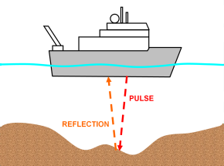
- Multiply this by the speed of sound in sea water ( x 1500 m/s)
Depth (m) = speed (m/s) x time (s)

Calculate the following depths assuming speed of sound in sea water = 1500 m/s.

It took 0.4s for a sound pulse from a ship to return. What is the depth of the water?

Calculate the depth of the fish, given that the sound took 1 second to return.

Think about it!

When there is a storm, why do you always see the lightning before you hear the ‘boom’ of the thunder?
__________________________________________________________________________________
__________________________________________________________________________________

Fighter jets can create sonic booms that are capable of smashing windows! Briefly describe how this can happen.
__________________________________________________________________________________
__________________________________________________________________________________
__________________________________________________________________________________
__________________________________________________________________________________

Why are ‘sound rooms’ where bands often practise covered with bumpy, soft cushioned material?
__________________________________________________________________________________
__________________________________________________________________________________
__________________________________________________________________________________
__________________________________________________________________________________
__________________________________________________________________________________
__________________________________________________________________________________
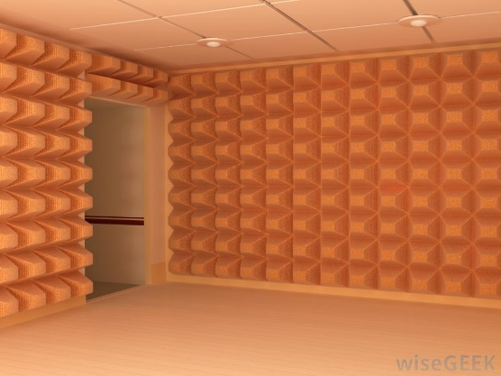

Sound proof room material

Frequency and Pitch

What does a cathode ray oscilloscope (CRO) measure?
__________________________________________________________________________________
__________________________________________________________________________________
What is frequency?
__________________________________________________________________________________
__________________________________________________________________________________
What is frequency measured in?
__________________________________________________________________________________
__________________________________________________________________________________
What is wavelength?
__________________________________________________________________________________

Draw a sound wave for:
(Label the following on each diagram: wavelength, amplitude, trough, crest)
A softer, quieter sound:
A loud sound:

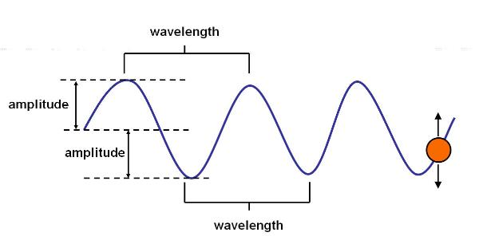
Use this diagram to help you!
What is the Doppler effect? Give an example of when you would experience this.
__________________________________________________________________________________
__________________________________________________________________________________
__________________________________________________________________________________
__________________________________________________________________________________
__________________________________________________________________________________

Describe how ultrasound is different to infrasound.
__________________________________________________________________________________
__________________________________________________________________________________
__________________________________________________________________________________
__________________________________________________________________________________
__________________________________________________________________________________

Describe how each of the following instruments produces sound.

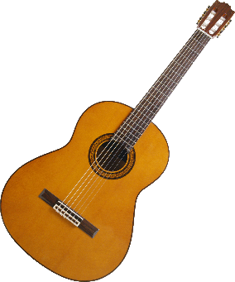

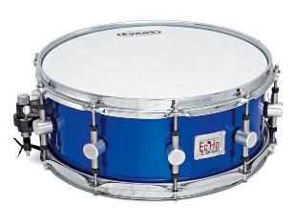

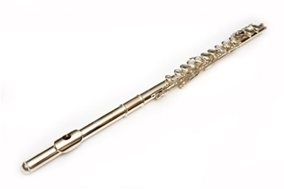

The ear collects sound waves, amplify their vibrations and convert these into electrical impulses. Your brain then interprets these impulses as sound. (You will need to add the pinna, oval window and auditory nerve to this diagram below. Note: hammer, anvil and stirrup = the ossicles)
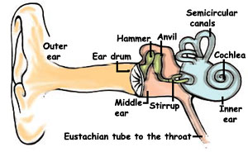

Draw vertical lines
to show the outer,
middle and inner ear

Eardrum:
__________________________________________________________________________________
__________________________________________________________________________________
__________________________________________________________________________________
Pinna:
__________________________________________________________________________________
__________________________________________________________________________________
__________________________________________________________________________________
Oval Window:
__________________________________________________________________________________
__________________________________________________________________________________

Semicircular canals:
__________________________________________________________________________________
__________________________________________________________________________________
__________________________________________________________________________________
Auditory nerve:
__________________________________________________________________________________
__________________________________________________________________________________
__________________________________________________________________________________
Cochlea:
__________________________________________________________________________________
__________________________________________________________________________________
__________________________________________________________________________________
Eustachian tube:
__________________________________________________________________________________
__________________________________________________________________________________
__________________________________________________________________________________
The Ossicles:
__________________________________________________________________________________
__________________________________________________________________________________
__________________________________________________________________________________

Explain how exposure to high noise levels (>85dB) can permanently damage your hearing. Reference the condition tinnitus within your answer. Note: dB = decibels, measure of ‘loudness’.
__________________________________________________________________________________
__________________________________________________________________________________
__________________________________________________________________________________
__________________________________________________________________________________
__________________________________________________________________________________
__________________________________________________________________________________
__________________________________________________________________________________
__________________________________________________________________________________

